Naive RAG versus Enhanced RAG
A Comparative Evaluation of Hallucination Mitigation Techniques
Ajay Bhuj
Student number: 25051512
MSc Data Science
UFCF9Y-60-M CSCT Masters Project
Supervisor: Dr. Kamran Soomro
School of Computing and Creative Technologies
University of the West of England, Bristol
September 2025 - 2026

Abstract
Large language models answer questions about documents and papers directly but have a tendency to hallucinate confident answers which are unsupported by the text they are reading from, undermining their use in research and careful reading where getting the wrong answer without noticing seems easy. Retrieval-augmented generation addresses the issue, grounding answers in text retrieved from the broader collection at the same time as returning them, and many techniques enhance this effect. Yet each of these techniques has been tested separately against a naive baseline so that there is no like-for-like comparison of the various methods across the same documents, questions, and metrics. The aim of this project is to put that right, with the intention of finding which technique works best at reducing hallucination and which stage in the pipeline matters most. I have set up a web-based platform that runs a naive baseline answer on the same set of questions and test documents as it runs seven enhanced retrieval-augmented generation techniques through three stages of the process (before, during, and after retrieval) and scores the outputs on four RAGAS metrics, judged with a fixed text-judge model, both for a benchmark of factual, synthesis, and out-of-scope questions over several papers and an experiment that looks at performance as the paper collection grows in size. Contextual compression was the most effective technique as it raised faithfulness from 0.75 to 0.86 and roughly halving hallucination on overall papers, while it alone stayed faithful on out-of-scope questions, with the other pipelines fabricating. Cross-encoder re-ranking gave the best retrieval and held up best as the collection grew, while Maximal Marginal Relevance was the only technique that made matters worse. The results suggest that post-retrieval compression is the best intervention point, while cross-encoder re-ranking is the way to go if you expect your collection to grow. The open and reproducible platform can be used by anyone to repeat the comparison or to extend it to their own material.

Use of AI declaration

I have used AI tools such as ChatGPT, Claude and Gemini as a supplementary aid during the development of this dissertation and project artifact. I have used the tool to correct grammar and language errors, to improve the structure and organisation of the text, to learn related concepts (such as Retrieval-Augmented Generation, RAG enhancement techniques, and advanced approaches to implementing a RAG pipeline), and to identify potential bugs and other errors in the project artifact.

I have not used AI to generate the dissertation or source code. My original work for the project includes project design, implementation, code, experimentation, analysis, evaluation, and conclusions. While I sometimes used AI suggestions as guidance, I always independently reviewed, tested, and adapted these recommendations. The work presented in this dissertation is my own and I take full responsibility for it.

TABLE OF CONTENTS

Abstract 2
Use of AI declaration 3
Chapter 1: Introduction 6
1.1 Context 6
1.2 Motivation 6
1.3 Problem statement and scope 7
1.4 Aim, research questions and objectives 7
1.5 Contribution 8
1.6 Success criteria 8
1.7 Structure of the report 9
Chapter 2 Research 10
2.1 Hallucination and why it must be measured 10
2.3 Why these techniques, stage by stage 11
2.4 Why RAGAS and why these four metrics 13
2.6 The gap this project fills 14
Chapter 3: Proposed Artefact 15
3.1 The proposed Artefact 15
3.2 Design Principles 16
3.3 How the artefact relates to the aims 16
Chapter 4: Design, Architecture and Methodology 17
4.1 System architecture 17
4.2 Requirements 18
4.2 Tools and techniques 18
4.3 Methodology 19
Chapter 5: Implementation 20
5.1 Code structure 20
5.2 The naive baseline 20
5.3 Pre-rerieval techniques 20
5.4 During retrieval techniques 21
5.5 Post retrieval techniques 21
5.6 Evaluation and result persistence 21
5.7 The web application 22
Chapter 6: Ethical, Legal and Professional Considerations 26
6.1 Ethical considerations 26
6.2 Legal considerations 26
6.3 Professional considerations 27
Chapter 7: Evaluation and Results 28
7.1 Experimental design 28
7.2 Technique Comparison 28
7.3 Stage Attribution 30
7.4 Performance vs Corpus Size 30
Chapter 8: Conclusion and Reflection 33
8.1 Project Summary 33
8.2 Result Summary 33
8.3 Extent to which the aims were met 33
8.4 Reflection 34
8.5 Future work 34
References 36
Appendix A: Ethical Review Form 39
Appendix B: Record of supervision Meetings 42
Appendix C: Gantt Chart 43
Appendix D: Benchmark Schema Example: 43
Appendix E: Pipeline Design 44

Table of Figures
Figure 1 : The eight pipelines across the three RAG stages. 15
Figure 2 : The system architecture. 17
Figure 3 : The interactive Page 22
Figure 4 : Batch Run page 23
Figure 5 : Corpus experiment Page 24
Figure 6 : Result page for Batch evaluation 25
Figure 7 : Faithfulness for each pipeline compared against naive baseline 29
Figure 8 : Faithfulness by question category for the naive baseline and compression 30
Figure 9 : Context Recall of each pipeline vs the corpus size 31
Figure 10 Faithfulness against all techniques 32
Figure 11 : Answer Relevency against all techniques 32
Figure 12 : Context precision against all techniques 32
Figure 13 : Context Recall against all techniques 32
Figure 14 : The naive RAG baseline. 44
Figure 15 : The three retrieval stages. 45
Figure 16 : Multi-query retrieval. 46
Figure 17 : Cross-encoader reranker 47
Figure 18 : SelfCheckGPT 48
Figure 19 : Contextual compression 49
Figure 20 : CRAG, corrective retrieval 50

Chapter 1: Introduction

Context
Large language models have completely changed how people obtain information from documents. They allow users to ask a question in plain language and immediately receive the most relevant answer in a well-formed natural language response. This aspect is particularly appealing for dense technical materials such as scientific papers, where large language models can save great effort. However, a problem is that large language models do not reason about documents logically but generate answers on the basis of statistical patterns they have observed in their training data. As a result, the answers they provide can be factually wrong or can include information that is not supported by any content of the input documents. This issue is referred to as hallucination and renders the system untrustworthy for serious concerns. A way of significantly reducing hallucination is retrieval augmented generation, which has become important in recent years. The key idea in retrieval augmented generation is simple: first retrieve a few relevant chunks from a large collection of documents and then ask the large language model to generate an answer based on the question and the selected chunks. It also allows the large language model to answer questions about documents it has never seen before. A naive implementation of the pipeline can fail at different stages of the answering process. Retrieval can return the wrong chunks, or it can return nothing at all that is useful for generating an answer. The large language model can return a response that contradicts or simply ignores the retrieved chunks. Some techniques to strengthen each part of the pipeline have been proposed already, and many more are expected to follow.

Motivation
Many different techniques have been introduced to solve hallucination at different stages within the retrieval augmented generation pipeline. Until now, most of these techniques have been studied in isolation on different data, with being compared to a single naive baseline. There is currently no common system within the literature that places these different techniques side by side in the same system, under the same metrics. In most other systems, only a limited subset of techniques have been compared to this naive baseline. This makes it hard to know which stage of the pipeline (input, retrieval, or output) would be the most promising place for intervention to reduce hallucination. The motivation for this project was the absence of a controlled system to compare different techniques to each other within different stages of the pipeline.

Problem statement and scope
There is currently no single reproducible way to compare hallucination mitigation techniques for retrieval augmented generation or to determine which stage of the pipeline contributes most to hallucination. This project contributes such a method by evaluating retrieval augmented question answering over research papers with a naive baseline and seven techniques enhanced in one of three stages of the pipeline. The same set of benchmark questions is used for all pipelines. The quantitative results I report, answer faithfulness and answer relevance, as well as retrieval quality and response time, are shared across all techniques and stages. Secondary results are also reported that examine these metrics as the corpus of documents grows, still limited to English-language text-only documents.

Aim, research questions and objectives
The aim of this project is to design, build, and evaluate a web system which will compare how the addition of a variety of enhanced pipeline techniques to a simple, naive RAG pipeline reduces the tendency of the system to hallucinate when answering questions about any document.
Our work is guided by two primary research questions:
RQ1: How much does each enhanced technique reduce hallucination and increase faithfulness of the answer compared to the naive RAG baseline?
RQ2: Which stage of the RAG pipeline is most effective in reducing hallucination?
The following objectives are pursued:
- Design and implement baseline Naive RAG pipeline by the end of week 3 that will accept arbitrary documents, answer user-defined questions using retrieved document content, and quantitatively evaluate answer quality using four predefined metrics.
- By the end of Week 7, implement and conduct a quantitative comparison between the baseline and seven advanced RAG techniques across the retrieval, augmentation, and generation stages under identical datasets, questions, evaluation metrics, and experimental conditions.
- As part of our project, I am aiming to complete by week 10 a web-based application that evaluates and supports single as well as batch (simultaneous) evaluation of questions, generated answers, and reports quantitative scores over four predefined evaluation metrics.
- To measure the effect of increasing document size on RAG answer quality using at least five document-size levels, and to visualise and analyse the resulting relationship using a line chart by the end of week 11.

Contribution
This project makes three major contributions. First, it offers a single, reproducible web platform where naive baseline can be evaluated along with other seven mitigation techniques under identical conditions. Second, it also help in identifying the strongest individual technique along with the most effective point of intervention in the pipeline. Third, it provide an study which shows how the RAG performance get affected as the document collection grows.

Success criteria
I consider the project a success if the following conditions are true:
1. The naive baseline and all seven enhanced techniques run end-to-end 15 question benchmark and return the four metrics without error.
2. The application produces clear comparative results that address RQ1 and RQ2.
3. The application reveals a clear relationship between collection size and performance that will yield interpretable results

Structure of the report
Chapter 2 reviews the literature on LLM hallucination, RAG, seven hallucination-mitigation techniques, evaluation metrics, and the user needs addressed by this project. Chapter 3 presents the proposed artifact and its objectives. Chapter 4 describes the system architecture, eight pipelines, tools, and methodology. Chapter 5 explains the evaluation process and four metrics. Chapter 6 discusses ethical, legal, and professional considerations. Chapter 7 presents and analyses the results and threats to validity. Finally, Chapter 8 summarises the findings and suggests directions for future work.

Chapter 2 Research

2.1 Hallucination and why it must be measured
As we've discussed in the introduction, a language model answers a question by predicting what text is likely to occur, rather than by consulting all the relevant sources of truth, so it sometimes produces a fluent but quite wrong answer or one that contains statements not supported by the input.
Ji et al. 2023 mapped this failure in detail, gave it a name (hallucination), and described types of it, as did Huang et al. (2024), who also discuss difficulties of measurement. This section is a concise summary of the two.
Ji et al. were the first to describe hallucination in natural language generation and they separated intrinsic hallucination (an output that contradicts its source, which can be checked) from extrinsic hallucination (an output that cannot be checked against any source).
Huang et al. argue that it needs to be redrawn to take account of modern open-ended models, distinguishing between factuality hallucination (a departure from real-world facts) and faithfulness hallucination (a departure from the given input).
Huang et al. also note that retrieval does not remove hallucination, which is why our project studies mitigation rather than assuming that retrieval alone suffices.

2.2 Motivation and Limitation of Naive Pipeline
An approach called retrieval-augmented generation, introduced by Lewis et al. (2020), pairs a model with a searchable index of facts to help it generate answers grounded in retrieved text. The model using retrieval was reported to use more factual language than one without retrieval. Since then, retrieval has been the standard response to hallucination and is the foundation of every pipeline here. Gao et al. (2024) organized the field into a naive retrieval paradigm, in which the model simply has access to a retrieval mechanism; an advanced one, in which the retriever itself is more sophisticated; and a modular one, in which retrieval is a separate module, which takes a query as input and returns candidate answers as output. The pair of advanced steps acting before and after retrieval give the project its structure. Rather than asking which is the best technique for eliminating hallucination, I'm now asking which stage of the pipeline to improve.
A naive pipeline is not enough on its own. Barnett et al. (2024) studied three deployed systems and named seven failure modes, including situations in which the system retrieved nothing useful, ordered the retrieved passages badly, or generated a response that ignored the retrieved answer. Liu et al. (2024) showed that models used information poorly when it sat in the middle of a long input. Simply retrieving more text can sometimes lower quality rather than raise it. Together, these two papers justify treating retrieval as something to strengthen at several points rather than as a solved step.

2.3 Why these techniques, stage by stage
This project has chosen seven enhancements, each acting at one stage in the pipeline and addressing one documented failure.
Pre-retrieval:
All retrieval begins by chunking the paper into passages. Gunther et al. (2024) show that splitting into isolated chunks of fixed size causes each chunk to lose its context, making retrieval impossible. To better preserve meaning while reducing chunking-induced noise, chunking is treated as a technique in its own right in this project. It compares a plain fixed-size splitter against one that splits where the meaning changes.
Gao et al. (2023) use a retrieval step that first guesses a hypothetical answer to the query then retrieves documents containing it. Unfortunately, the generated text is unreal and often contains fantastic details. As that property is unacceptable for an experiment aiming to reduce hallucinations, this project instead generates several genuine rephrasings of the question for the computer to search for. While genuinely rephrasing a query harms its precision, their retrieval sensitivity selects better rephrasings than the first round of prompting produces.

Retrieval:
Three techniques then act on what is fetched during retrieval. Carbonell and Goldstein (1998) proposed Maximal Marginal Relevance as a way of re-ranking retrieval results. It tackles the context duplication that Barnett et al. (2024) show makes retrieval insensitive to the task of retrieval-augmented generation. It improves results while remaining interpretable through a single number. Nogueira and Cho (2019) show a cross-encoder that reads the query and passage together before ranking them far more accurately than a separate-embedding similarity which only reads each one. While not all interfaces for large language models permit it, they do support a cross-encoder separate from the generation interface and containing no hallucination detection at all. It is able to boost the previous best by about twenty-seven per cent on a large passage-ranking benchmark, so this project applies one to its shortlist. Yan et al. (2024) additionally add corrective retrieval that starts by judging the quality of its own first retrieval then reacting. Having its behavior change in response to bad retrieval is the only means it has to escape failure, making such corrective retrieval the only candidate that genuinely holds retrieval-augmented generation to its own promise. Self-RAG (Asai et al., 2023) is a related approach that trains the model to decide for itself when to retrieve and to critique its own output. This kind of feedback is valuable but not universally supported, so the project deliberately removes the fallback to a plain web search that Yan et al. (2024) place on top of their other improvements. Then it rests entirely inside the text so it can be compared fairly with other answers extracted from a single paper.

Post-retrieval:
Two techniques then act on the answer after retrieval. Xu, Shi and Choi (2023) prove that compressing retrieved passages into short summaries improves accuracy while keeping only what is useful. They compress retrieved text into summaries of as little as six per cent its length at very little cost to performance, so this project applies compression to remove what is noise instead of only saving space. Manakul, Liusie and Gales (2023) detect hallucination without either an external database or model probability information, observing that overconfident answers ought to agree with one another whereas less certain ones ought not.

2.4 Why RAGAS and why these four metrics
RAGAS is a package that makes it easy to score answers using several metrics without requiring human reference answers and can be integrated into a standard evaluation framework for our project. In their work on Retrieval Augmented Generation, Es et al. (2023) introduced RAGAS and proposed hallucination as a signal for faithfulness. They compute a faithfulness score by breaking the answer into claims and checking what fraction is supported by the retrieved context. Our main alternative, the alternative evaluation strategy (ARES) by Saad-Falcon et al. (2024), is not used here because of the significant setup cost of training your own judges of faithfulness on synthetic data annotated by humans.

I choose four metrics, deliberately split into two pairs: (faithfulness, answer relevancy) and (context precision, context recall). Our faithfulness judge checks whether the generated answer makes claims that are grounded in the retrieved passages, and our answer relevancy judge checks whether the answer addresses the question at all. Our context precision judge checks whether the retrieved passages are relevant enough, and our context recall judge checks whether the needed passages were retrieved at all. Splitting the four metrics into two pairs makes it possible to tell which side, generation or retrieval, the score change is coming from.

2.5 User Needs
This artifact addresses three related needs that arise when engineers and researchers choose a retrieval technique for use in a document assistant. In many cases, there is no easy way to compare competing techniques on their own material, forcing such choices to be made on the basis of reputation rather than evidence. The first need here, therefore, is for choice of technique to rest on evidence. For these tasks, several promising retrieval techniques can be identified, but with little in the literature to guide reliable comparisons. It is this paucity of evidence that the artifact addresses. The second need is for the reasoning behind an answer to be visible so that its score can be trusted rather than taken on faith. The third need is for runs to be reproducible so that comparisons can be repeated and defended. Thus, the artifact is structured as an interactive mode that shows retrieved passages for a single question and a batch mode that scores a whole benchmark under fixed conditions.

2.6 The gap this project fills
Research on retrieval-augmented generation has proliferated in recent years. But still, there is a lack of direct comparison between such techniques under a shared evaluation protocol. In most cases, a technique's pluses are measured against a naive baseline in a vacuum. Broad surveys have catalogued various retrieval-augmented generation techniques, but none have run them against one another in any controlled fashion, whether applied to the same documents and questions or measured under the same yardsticks. There is no systematic attempt to benchmark the different candidate methods. This project fills that gap with a controlled and reproducible comparison. Among other things, it contrasts a naive baseline with seven enhancements, each isolated to just one stage of the retrieval-augmented generation process. Outputs of all competing approaches are evaluated by a fixed judge, while for the sake of fairness, retrieved context is shown for every answer. Subsequent chapters describe the artifact that enables such a comparison to be made and the findings it enables to be drawn.

Chapter 3: Proposed Artefact

3.1 The proposed Artefact
The artefact is a full-stack web application, with a Python backend and a React frontend, that implements a naive RAG baseline and seven enhanced hallucination-mitigation techniques behind a single interface so that all eight can be scored on equal terms. A user uploads a paper as a PDF, and the system then offers two modes. Interactive mode answers one question at a time and displays the answer, the retrieved passages, and the scores side by side. Batch mode runs a prepared benchmark of factual, synthesis, and out-of-scope questions end to end and returns per-question and averaged scores as a CSV. Every pipeline is scored on the same four RAGAS metrics by the same judge model, and a separate corpus experiment re-runs the same benchmark as the collection of papers grows. The deliverables are the web application, the eight pipelines, and two aggregated result tables holding per-question and averaged scores for analysis.
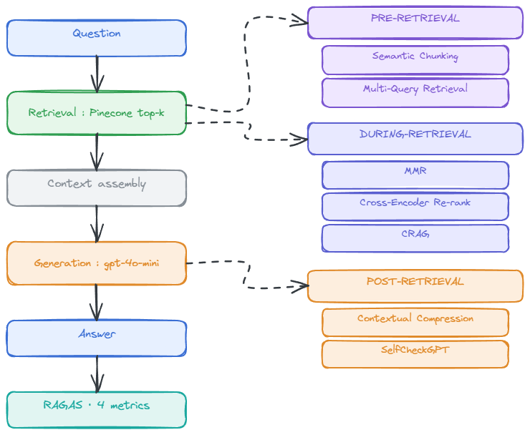

Figure 1: The eight pipelines across the three RAG stages.

3.2 Design Principles
Three main principles governs the design of the artefact.The first principle is single variable isolation where each enhanced technique changes while the naive pipeline remain constant so that each technique can be compared against it. The second principle is like for like measurement where all the pipelines goes through same questions for the same documents, and same metrics are used for all the questions and pipelines. The third principle is reproducibility which is achieved by creating a validated schema where every benchmark is a stored file. Each of the result file contains the pipeline, the question and the retrieved passages that provided it.

3.3 How the artefact relates to the aims

The artifact described in this paper meets all four of the project aims. It provides the baseline Naive RAG pipeline, seven enhanced versions of that pipeline, and a web application through which the user can perform interactive or batch evaluation. A validated benchmark covering factual, synthesized and unanswerable questions provides an opportunity for consistent, comparable question answering and a means of evaluating model pipelines in this area. The batch runner, in particular, enables an understanding of which techniques and which stages in the pipeline prove most effective. In addition, a simple experiment with a different document corpus can be performed to explore the effect of varying the number of documents used. The primary novelty introduced by this artifact is the ability to compare directly the baseline pipeline with all seven of the enhanced techniques, while using the same set of documents and the same questions and four automated evaluation metrics.

Chapter 4: Design, Architecture and Methodology

4.1 System architecture
The pipeline is organized into three stages, as outlined in Figure 2, which also indicates how the three stages connect.
Each paper is parsed to text and split using two chunkers. Both chunkers separately place boundaries within the text. Fixed chunking splits the text into 1,000-character chunks overlapping at 200 characters. This was selected so that each chunk contains the equivalent of one paragraph with any sentences that cross boundaries appearing intact in neighboring chunks. The second chunker employs similarity-based splitting, which places boundaries where the embedding similarity between consecutive sentences falls below a specified threshold. Both sets of chunks are embedded using text-embedding-3-small, then written to one Pinecone index under separate namespaces. 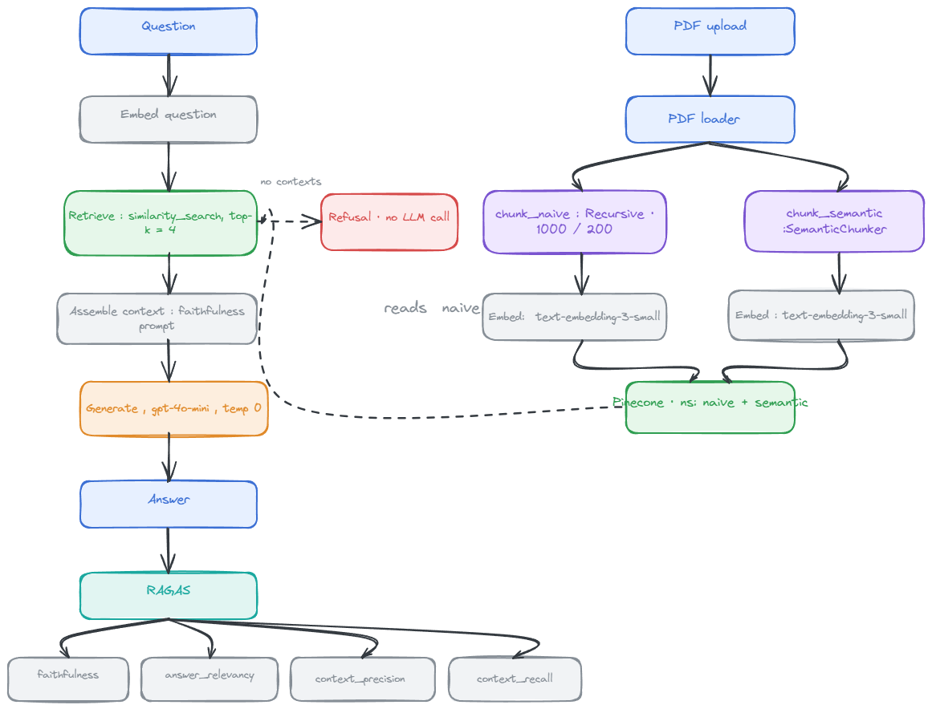
Figure 2: The system architecture.

4.2 Requirements
The user needs identified in Chapter 2, and objectives identified in Chapter 1, form the basis of the following functional requirements. The system must ingest a PDF paper and apply two chunking strategies to produce two sets of chunks, then index each set of chunks. The answering need drives the system to respond through the naive baseline or any of the seven enhanced pipelines, returning the retrieved passages along with four RAGAS metrics for every answer.
Two working modes are required: An interactive mode that answers a single question, showing the answer, retrieved passages, and scores together. And a batch mode that runs a whole benchmark start to finish, returning per-question and averaged scores as a CSV. The demand for a corpus experiment requires that the collection keeps growing while the retrieval stays limited to a chosen subset of papers.

4.2 Tools and techniques
Generation and evaluation both use gpt-4o-mini at temperature 0 to reduce model-related confounding, while keeping API costs manageable, although this introduces potential self-preference bias. text-embedding-3-small (1,536 dimensions) is used for document indexing, question embedding, and semantic chunking. Pinecone is used as the vector store because its namespaces separate chunking conditions and metadata filtering supports controlled corpus experiments. The pipelines are implemented using LangChain, with a FastAPI backend and React/TypeScript frontend.
Table 1: Software environement
Component | Package
Language | Python
RAG Framework | langchain
Evaluation Framework | RAGAS
Vector store | Pinecone-client
Re-ranking | Sentence-transformers (ms-marco-MiniLM-L-6-v2)
Backend | FastAPI, Uvicorn
Frontend | React, typescript, vite

4.3 Methodology
Throughout this dissertation, I used an incremental, verification-driven development approach with small steps and extensive testing at each step. Every decision I make during this process is recorded. My benchmark-driven evaluation is designed to be entirely reproducible with my own work and the work of others. Every benchmark conforms to a well-defined schema that is itself validated by the same scheme as the others. Every question has a unique ID and has a known ground truth when it is answerable. The generator and judge settings are fixed in advance and do not change during any run of evaluation. Every run stores the full generator and judge output, as well as the score per question, the retrieved passages, and timing in versioned files (for each run of evaluation).

Chapter 5: Implementation

5.1 Code structure
The backend is a FastAPI application for ingestion, question answering, and answer scoring. Every tunable value is in a single settings module. A group of routers for the frontend provides upload, ask, batch, benchmark, corpus, and results endpoints.
Every pipeline declares its identifier, the stage it corresponds to, and a Pinecone namespace for vectors. Every pipeline has a single run method which takes a question and shared context, and returns answer, passages, and stage timings.

5.2 The naive baseline

The Naive RAG retrieval and generation path goes through the Naive namespace. Like all endpoints, the first thing this pipeline does is embed the question and run a similarity search for the four nearest chunks in the naive namespace. It then formats those passages into the shared prompt and generates with gpt-4o-mini at temperature zero. If the search returns nothing, the pipeline returns the fixed refusal string and does not call the model at all.

5.3 Pre-rerieval techniques

Semantic chunking reads its chunks from the semantic splitter instead of the naive, fixed-size splitter, and otherwise inherits all steps unchanged from the baseline.

Multi-query retrieval asks the model to produce three alternative phrasings of the question, which are then retrieved separately for the original question and each of its paraphrases. The retrieved results are merged together, with any duplicates removed by passage text (keeping the best score of any duplicates). If the paraphrase generation fails, it simply fall back to retrieving the original question.

5.4 During retrieval techniques
Maximal Marginal Relevance over-fetches twenty candidates and re-selects four while balancing similarity to the question against dissimilarity to already chosen passages.
Cross-encoder re-ranking also works by over-fetching twenty candidates and keeping the four highest scoring after re-scoring. This re-ranker reads the question and passage together rather than embedding each separately.
Corrective retrieval retrieves as the baseline does and asks the model to grade every retrieved passage as correct, ambiguous, or incorrect in a single call. If any passage is graded below correct, the model rewrites the question, and a second retrieval runs with the rewritten form.

5.5 Post retrieval techniques
Contextual compression over-fetches eight passages and asks the model once per passage in parallel. Extraction keeps only sentences that bear on the question, a passage with nothing relevant returns a sentinel value and is discarded entirely. Generation then runs over the surviving compressed text. When every passage is discarded, the model has nothing left to fabricate from.
SelfCheckGPT generates the baseline answer and three further samples at temperature 0.7 from the same prompt and passages. The main answer and samples are embedded, and mean cosine similarity provides a confidence signal. A mean below 0.85 causes a low-confidence caveat to be prepended to the answer.

5.6 Evaluation and result persistence
The metrics are driven through wrappers around the same chat model and embedding model used by the pipelines so that judge drift onto a different model version from the generator will be prevented. Faithfulness and answer relevancy are computed for every answer. Context precision and context recall are computed only where the benchmark supplies a reference answer.
A completed batch run writes three files. First, there is an append-only master file that accumulates one row for every combination of run, paper, pipeline, and question across the whole study. This is how cross-paper analysis is done. Second, there is a second file that holds the same rows for that run alone, as a convenience copy. Finally, there is a third file that holds the full record in JSON, including retrieved passages.

5.7 The web application
The frontend is a React and TypeScript application with pages for uploading a new dataset, interactive questioning through a series of user-selected pipelines, batch running on multiple benchmarks simultaneously, the corpus experiment which drives the scaling experiment, and a results page which renders stored runs as tables, grouped bars, and a trend chart across corpus sizes. The interactive page (Figure 3) answers a single question and shows the answer provided by each selected pipeline and what passages from the dataset it used to generate that answer. Each answer is also assigned a score based on a RAGAS metric relevant to the respective question type. The batch page (Figure 4) runs a full benchmark.

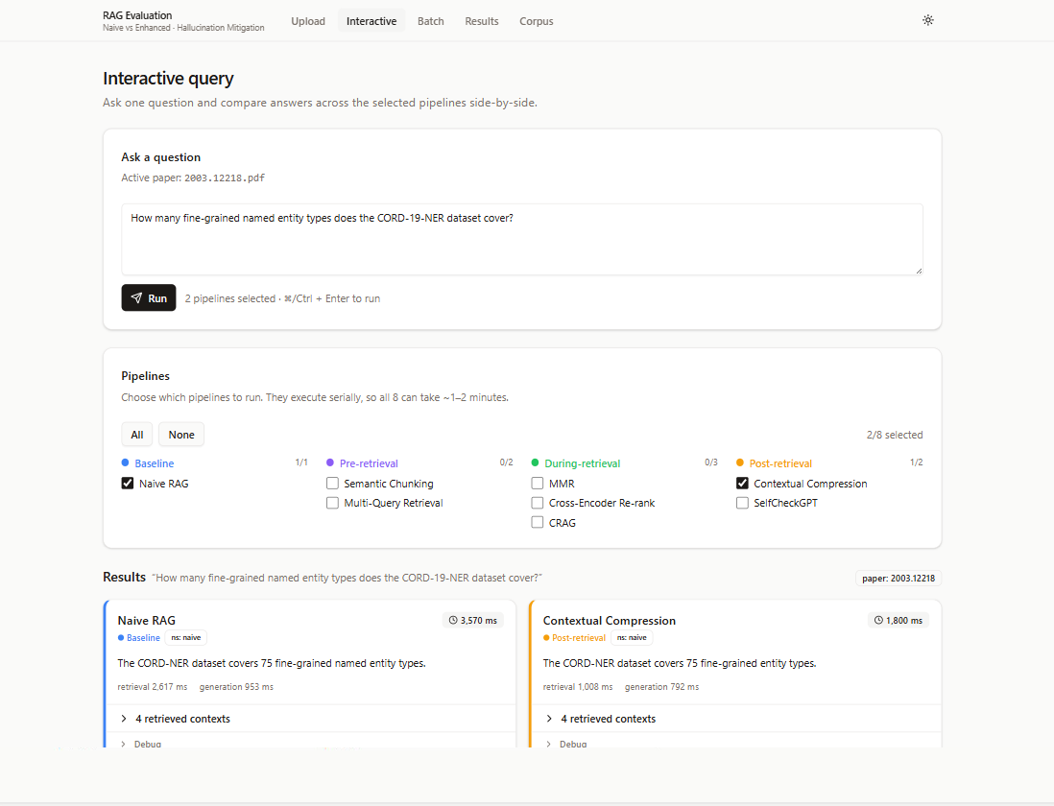

Figure 3: The interactive Page

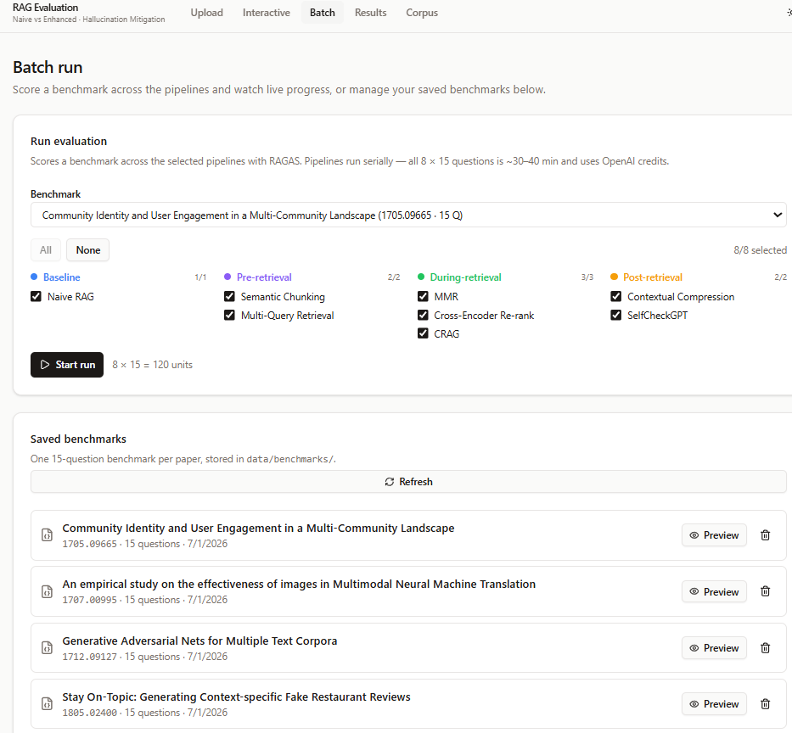

Figure 4: Batch Run page

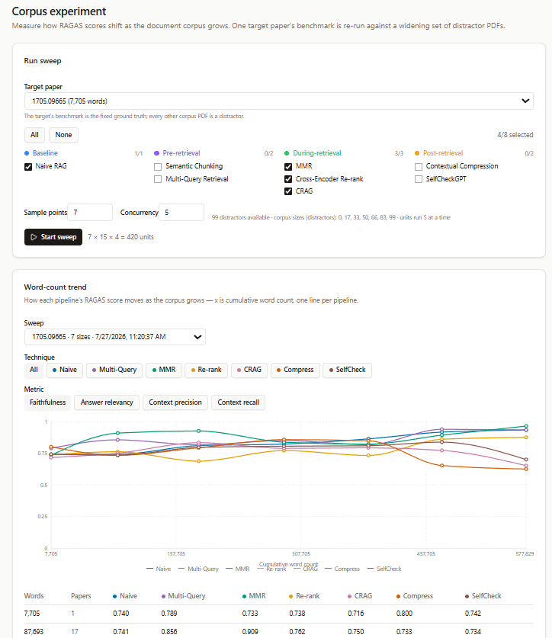

Figure 5: Corpus experiment Page

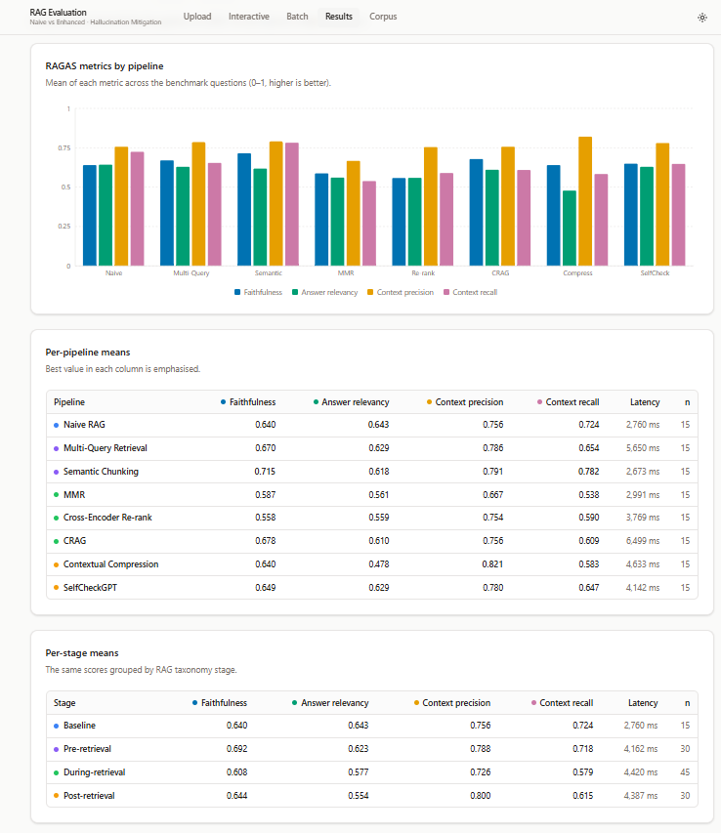

Figure 6: Result page for Batch evaluation

Chapter 6: Ethical, Legal and Professional Considerations

6.1 Ethical considerations

This project is ethically motivated because it addresses the risk to a reader of a document assistant giving a confident but false answer to a question where the answer cannot be easily verified.

In this case, no human participants were involved and no personal data were collected because the benchmark questions came from a public academic paper. Ethical record form stated that no human participants were involved and that no special ethical concerns arose, so no further approval was needed. The record is included in Appendix.

6.2 Legal considerations

The benchmark questions are drawn from the QASPER dataset, which is available under a Creative Commons license. The papers are preprints available from arXiv, which are used for research purposes only and not for any commercial purpose. The full text of each paper is read internally and is not redistributed in any form. The study only publishes its own material.

Generating the answers and scoring them runs through a commercial interface which sends passages from the paper to an external provider. The provider's policy states that submissions are not used for training by default and are retained only briefly for abuse monitoring purposes before being deleted (OpenAI, 2024).

No personal data relating to any living individual is collected or processed in this study, so the UK GDPR does not apply. Every dependency used is open-source software licensed under a permissive license. Every library that the system uses is an open-source software package under a permissive license.

6.3 Professional considerations

This work follows the British Computer Society Code of Conduct (BCS, 2022). It describes any limitations and shortcomings of the research. It rests on academic integrity and has been regularly supervised by the supervisor, with notes of supervision recorded in Appendix . It is kept open and reproducible. A different researcher should be able to rebuild this study and check it.
The project has been under continuous supervision, and a record of the meetings held and decisions made is given in Appendix B.

Chapter 7: Evaluation and Results

7.1 Experimental design
In this experiment, the naive baseline evaluation is compared against the seven enhanced pipelines using the benchmarks built from the qasper dataset (Dasigi et al., 2021). Each of the benchmark carries fifteen questions which are split into different categories such as eight factual questions, five questions that requires synthesis across multiple papers, and two questions that can not be answered. The four RAGAS metrics were used to evaluate each answers. The judge, its temperature and its system prompt are made constant across all the pipelines. The first research question is answered by comparing every enhanced pipeline against the naive baseline average score. The higher faithfulness score suggests there is less hallucination. The second research question is answered by comparing the scores of stages of the pipelines such as before , during or after retrieval.

7.2 Technique Comparison
The table below present the average score across all the evaluated document.
Pipeline | Stage | Faithfulness | Ans. relevancy | Ctx precision | Ctx recall | Latency
Naive | Baseline | 0.747 | 0.637 | 0.721 | 0.754 | 2.4 s
Semantic chunking | Pre | 0.751 | 0.645 | 0.700 | 0.785 | 3.6 s
Multi-query | Pre | 0.725 | 0.630 | 0.693 | 0.755 | 5.0 s
MMR | During | 0.694 | 0.551 | 0.651 | 0.650 | 3.1 s
Cross-encoder re-rank | During | 0.770 | 0.630 | 0.759 | 0.811 | 4.2 s
CRAG | During | 0.734 | 0.639 | 0.735 | 0.717 | 4.6 s
Compression | Post | 0.863 | 0.657 | 0.742 | 0.781 | 4.6 s
SelfCheckGPT | Post | 0.732 | 0.636 | 0.694 | 0.769 | 4.1 s

The highest faithfulness score is found to be in contextual compression which means , this is the best technique which helps in reducing hallucination. The faithfulness score is increased from 0.747 to 0.863 which roughly halves the hallucination rate, from about 25% to about 14%. When compared across all the advance technique, compression stands out with better faithfulness score. Xu, Shi and Choi (2023) propose that compressing the retrieved documents into short summaries before they reach the model could in showing that this technique can be implemented with little loss of accuracy.
The strongest technique for retrieval was found to be cross-encoder as the context precision and the context recall score was found to be best for any pipeline.
The lowest score were found in the maximal marginal relevance (MMR) on every measure. It affected the faithfulness along with answer relevancy and the context recall metric the worst. As suggested by Carbonell and Goldstein (1998), the rewarding novelty can degrade the relevant material out of all the chunks. All the other pipelines such as semantic chunking, multi-query, CRAG and selfcheckGPT around the naive baseline.
The sharpest evidence of hallucination comes from the out-of-scope questions. Most of the pipeline tend to fabricate the answer when the retrieved chunks are not present in the paper with the score ranging from 0.19 to 0.32 on faithfulness. The irrelevant passages are discarded for the compression pipeline and, also it declines to answer rather than making up answer. In this experiment, compression is found to be reliably.

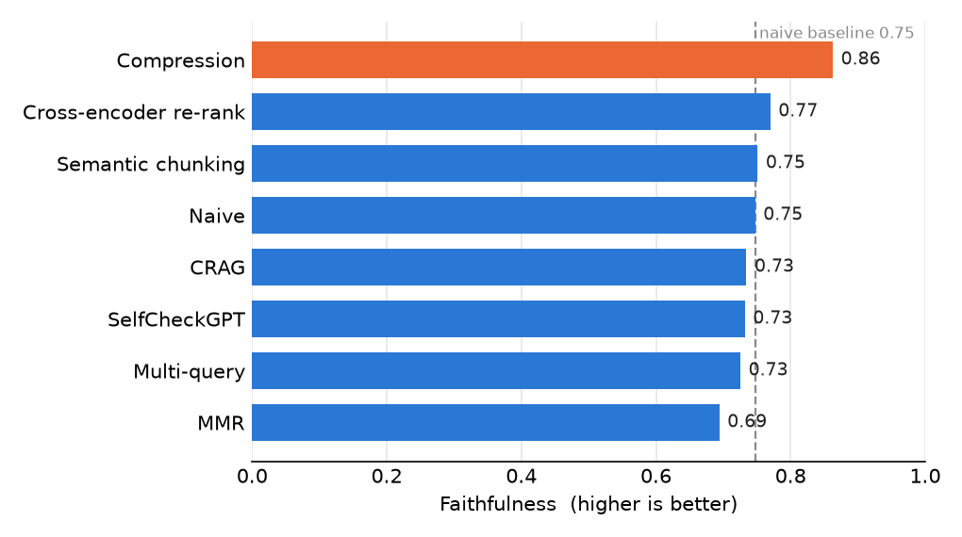
Figure 7: Faithfulness for each pipeline compared against naive baseline

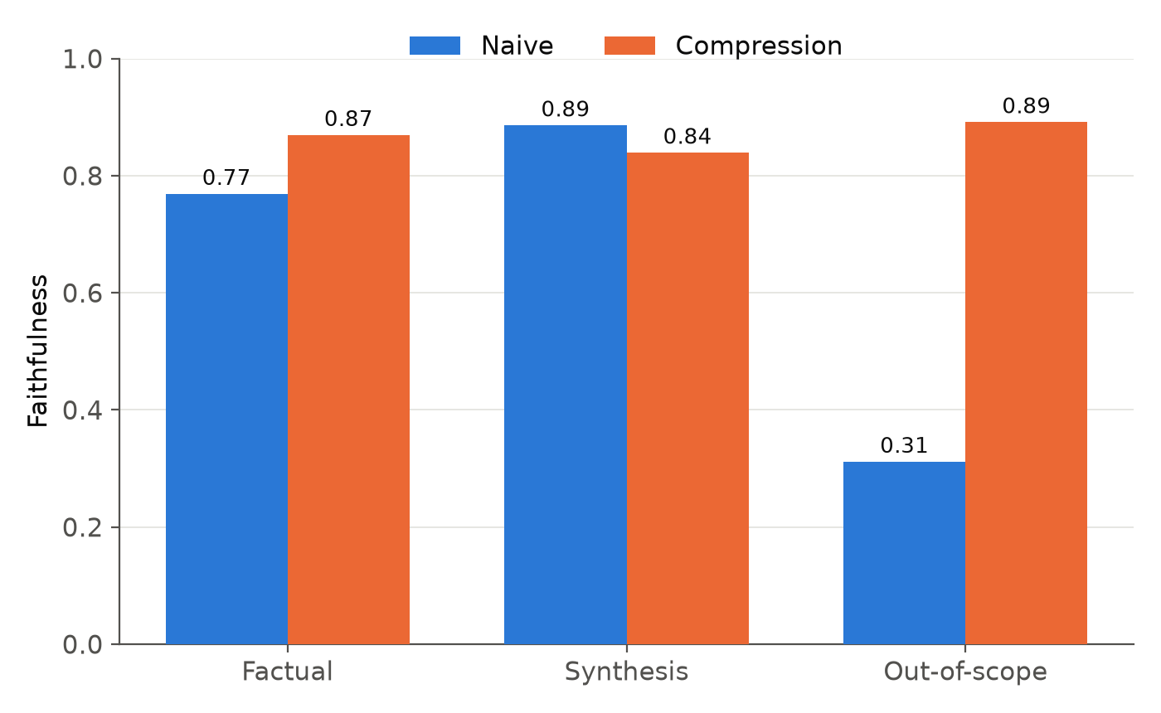
Figure 8: Faithfulness by question category for the naive baseline and compression

7.3 Stage Attribution
The second research question is answered by finding the mean score for each stage.The baseline score for naive is 0.747 on faithfulness. The per-retrieval stage scored an average of 0.738 and the during stage score an average of 0.733 which are both below the baseline. Only the post retrieval stage score improve at 0.797 on faithfulness. The winning stage is found to be post retrieval. Among all the post retrieval techniques, compression stands out and other post-retrieval technique sat level with baseline. Hence, the most effective stage is the post retrieval stage to reduce the hallucination.

7.4 Performance vs Corpus Size
The corpus experiment tested whether any advance technique can still find the right passage when the paper is buried among many large documents. In this experiment, the target paper is always kept fixed and unrelated papers were added around it which increases the word count to more than half a million words and the target’s question were re-scored at each step.
The Retrieval did not collapse as the corpus grew, since the relevant passages stayed findable among hundreds of papers. For most pipeline the context recall fell down as the size of the corpus grew. The cross encoder reranking’s context recall held steady and improved on as the corpus grew.
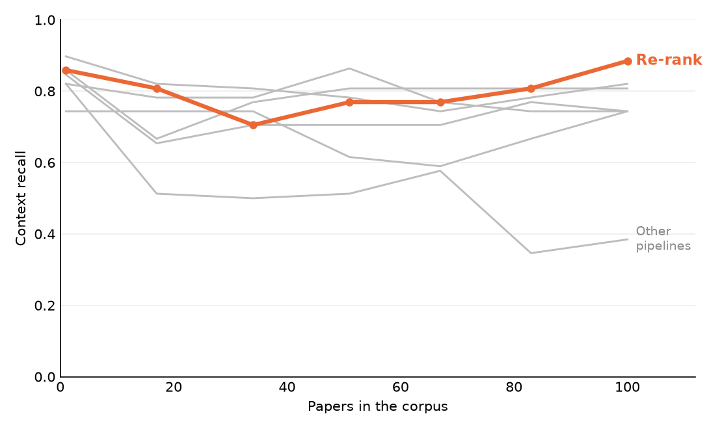
Figure 9: Context Recall of each pipeline vs the corpus size

Only the retrieval metrics are affected as the size of the corpus grew, and the reason is that the corpus is only visible to the retrieval step. As the generator and the judge does not directly have access to the whole corpus, but only the top four passages that are retrieved and passed on for answer generation. Context recall and context precision measure those fetched chunks against the answer the paper should give, so that they can register the change directly, as the chunks compete against each other and the unrelated chunks get discarded which have lower recall and precision. Faithfulness and answer relevancy does not check whether retrieval fetched the right passages. They only check whether the answer is supported by the passages that was given and the answer relevancy ask only whether the answer addresses the question. So, neither follow the size of the corpus as they only checks the retrieved chunks.

Result Screenshots For corpus Experiment:

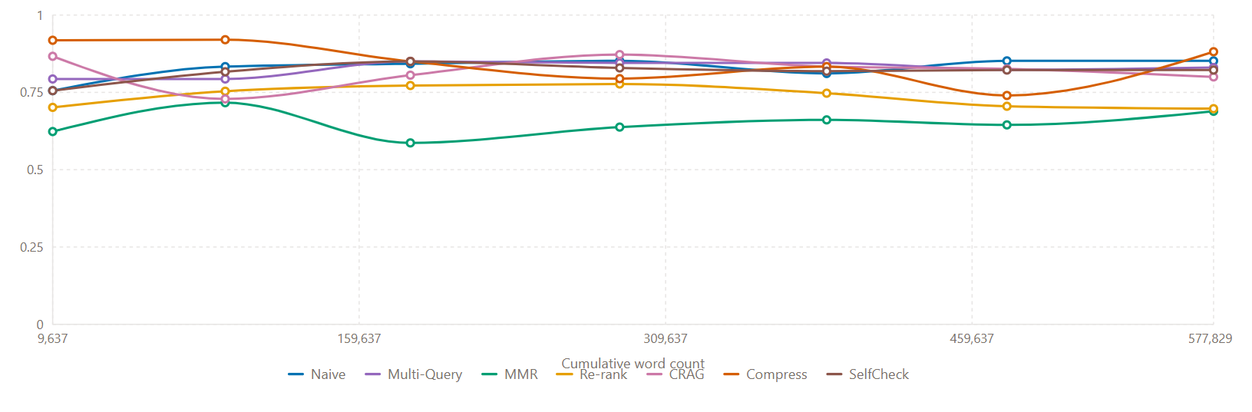
Figure 10 Faithfulness against all techniques

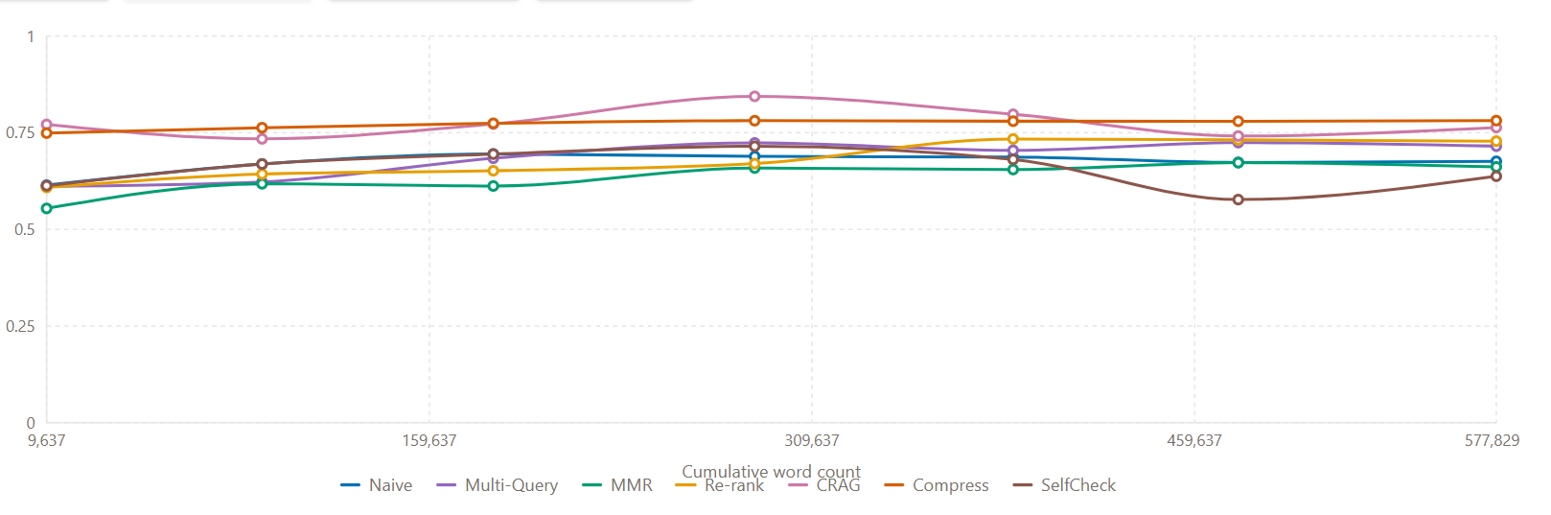
Figure 11: Answer Relevency against all techniques

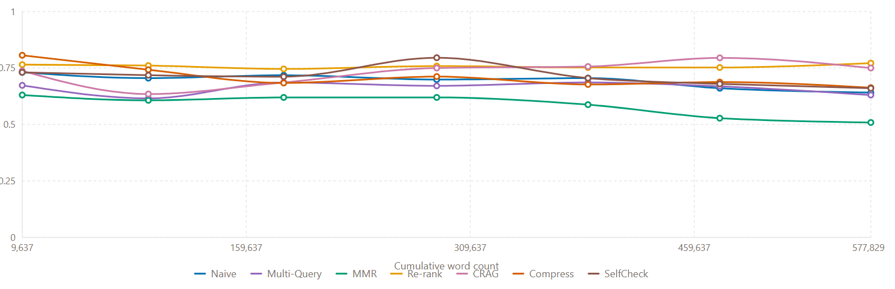
Figure 12: Context precision against all techniques

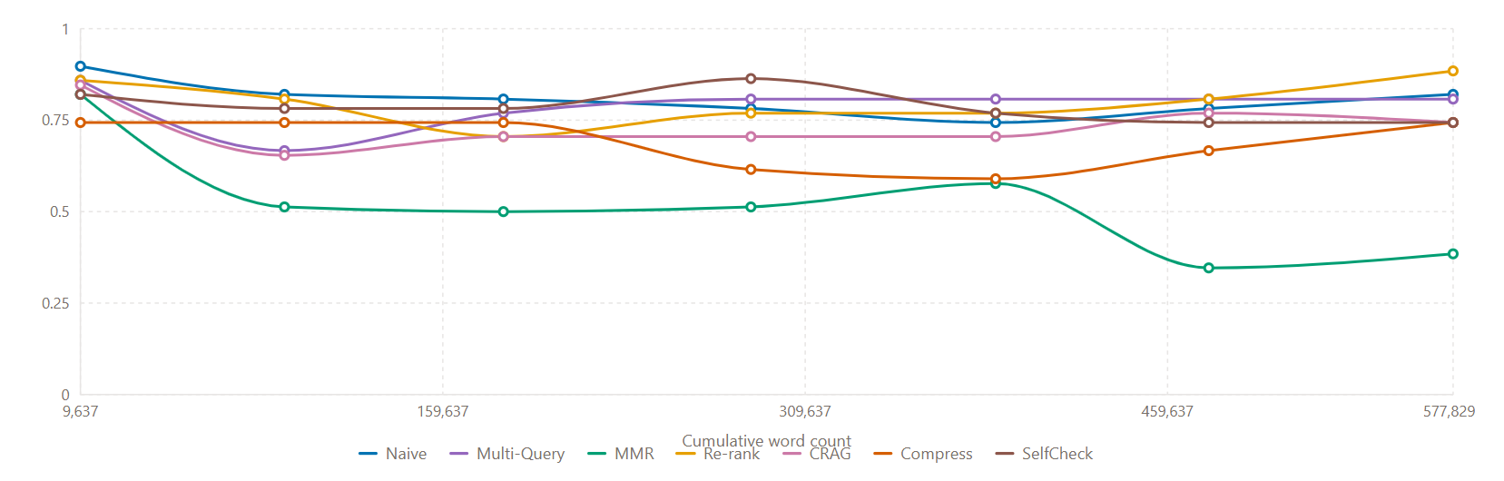
Figure 13: Context Recall against all techniques

Chapter 8: Conclusion and Reflection

8.1 Project Summary
This project is developed to answer a practical question that many papers left out which is to find the best technique for reducing hallucination in retrieval augmented generation and also to find out which stage of the pipeline is the best. A web-based system was built to run a naive baseline and seven enhanced pipelines over many documents to get scores for different RAGAS metrics and report the results through an interactive mode and a batch mode. In this experiment, all the techniques are spread into different categories such as before retrieval, during retrieval and after retrieval, and each one changed only a single stage so that any difference in the scores can be traced.

8.2 Result Summary
From this experiment, contextual compression was found to be the most effective technique for reducing hallucination which raises faithfulness from 0.75 to 0.86. Its clearest strength was on the out-of-scope questions, where it declined to respond rather than inventing an answer. Cross-encoder re-ranking was the strongest technique for retrieval and the most important as the document collection grew. It holds its recall while other techniques lost theirs. MMR was the worst technique that made the performance degrade. The remaining techniques could not be separated from noise as the score for these remain around the baseline. The most effective stage is found to be after retrieval whose compression technique stands out for reducing hallucination.

8.3 Extent to which the aims were met
All the aims and objective set out in this project was achieved. A naive baseline was built that answers questions about a paper and reports quantitative scores, and seven enhanced techniques were added alongside it, each reporting the same scores so that all eight pipelines could be compared directly. A single web application delivered both an interactive mode for exploring one question at a time and a batch mode for scoring a whole question set. Benchmark sets of factual, synthesis and unanswerable questions were brought in from QASPER datasets, with reference answers where they applied. The full comparison was then run and analysed, and the scaling experiment measured how retrieval and answer quality changed as the document collection grew.
Both research questions were answered, with compression identified as the strongest technique for reducing hallucination and the post-retrieval stage as the most effective point of intervention.

8.4 Reflection
The development followed an incremental and verification-driven plan, and building and testing each pipeline in isolation before moving on kept the comparison honest. Regular meetings with my supervisor helped a lot in refining the experiment. The corpus experiment idea came out of the supervision which was not in original proposal.

8.5 Future work
There are several ways in which this work could be extended in the future. One possible direction would be to move from the current fixed, single-stage pipelines towards a more agentic approach. Instead of following a predefined process, a language model agent could decide when it needs to retrieve more information, whether the retrieved evidence is sufficient, and when it has enough support to produce a final answer.
Another useful improvement would be to automate the entire evaluation process. This could include ingesting the research papers, running the different pipelines, evaluating the generated answers, and producing the final results tables in a single workflow.
Finally, future work could explore the use of the LangSmith framework alongside RAGAS. LangSmith could provide more detailed tracing of model calls, help manage datasets, and make it easier to track and compare experiments across different runs. Using both tools could therefore provide a broader and more transparent view of the system's performance.
Overall, these improvements could make the framework more flexible, easier to reproduce, and better suited for larger-scale evaluation in future research.

References
- Asai, A. et al., 2023. Self-RAG: learning to retrieve, generate, and critique through self-reflection. arXiv preprint arXiv:2310.11511. Available from: https://arxiv.org/abs/2310.11511 [Accessed 20 July2026].
- Barnett, S. et al., 2024. Seven failure points when engineering a retrieval augmented generation system. In: Proceedings of the 3rd International Conference on AI Engineering (CAIN 2024). Available from: https://arxiv.org/abs/2401.05856 [Accessed 18 May 2026].
- BCS, The Chartered Institute for IT, 2022. BCS Code of Conduct for Members. Swindon: BCS. Available from: https://www.bcs.org/membership-and-registrations/become-a-member/bcs-code-of-conduct/ [Accessed 20 August 2026].
- Carbonell, J. and Goldstein, J., 1998. The use of MMR, diversity-based reranking for reordering documents and producing summaries. In: Proceedings of the 21st Annual International ACM SIGIR Conference on Research and Development in Information Retrieval. Available from: https://doi.org/10.1145/290941.291025 [Accessed 20 August 2026].
- Creative Commons, n.d. Attribution 4.0 International (CC BY 4.0). Available from: https://creativecommons.org/licenses/by/4.0/ [Accessed 01 August 2026].
- Dasigi, P., Lo, K., Beltagy, I., Cohan, A., Smith, N.A. and Gardner, M., 2021. A dataset of information-seeking questions and answers anchored in research papers. In: Proceedings of NAACL-HLT 2021. Available from: https://arxiv.org/abs/2105.03011 [Accessed 20 August 2026].
- Es, S., James, J., Espinosa-Anke, L. and Schockaert, S., 2023. RAGAS: automated evaluation of retrieval augmented generation. arXiv preprint arXiv:2309.15217. Available from: https://arxiv.org/abs/2309.15217 [Accessed 15 August 2026].
- Gao, L., Ma, X., Lin, J. and Callan, J., 2023. Precise zero-shot dense retrieval without relevance labels. In: Proceedings of the 61st Annual Meeting of the Association for Computational Linguistics (ACL 2023). Available from: https://arxiv.org/abs/2212.10496 [Accessed 18 August 2026].
- Gao, Y. et al., 2024. Retrieval-augmented generation for large language models: a survey. arXiv preprint arXiv:2312.10997. Available from: https://arxiv.org/abs/2312.10997 [Accessed 10 July 2026].
- Gunther, M. et al., 2024. Late chunking: contextual chunk embeddings using long-context embedding models. arXiv preprint arXiv:2409.04701. Available from: https://arxiv.org/abs/2409.04701 [Accessed 14 August 2026].
- Huang, L. et al., 2024. A survey on hallucination in large language models: principles, taxonomy, challenges, and open questions. ACM Transactions on Information Systems. Available from: https://arxiv.org/abs/2311.05232 [Accessed 16 August 2026].
- Ji, Z. et al., 2023. Survey of hallucination in natural language generation. ACM Computing Surveys Available from: https://arxiv.org/abs/2202.03629 [Accessed 21 August 2026].
- Lewis, P. et al., 2020. Retrieval-augmented generation for knowledge-intensive NLP tasks. In: Advances in Neural Information Processing Systems 33 (NeurIPS 2020). Available from: https://arxiv.org/abs/2005.11401 [Accessed 20 August 2026].
- Liu, N.F. et al., 2024. Lost in the middle: how language models use long contexts. Transactions of the Association for Computational Linguistics, Available from: https://arxiv.org/abs/2307.03172 [Accessed 20 August 2026].
- Manakul, P., Liusie, A. and Gales, M.J.F., 2023. SelfCheckGPT: zero-resource black-box hallucination detection for generative large language models. In: Proceedings of the 2023 Conference on Empirical Methods in Natural Language Processing (EMNLP 2023). Available from: https://arxiv.org/abs/2303.08896 [Accessed 20 August 2026].
- Nogueira, R. and Cho, K., 2019. Passage re-ranking with BERT. arXiv preprint arXiv:1901.04085. Available from: https://arxiv.org/abs/1901.04085 [Accessed 20 August 2026].
- OpenAI, 2024. API data usage policies. Available from: https://openai.com/policies/api-data-usage-policies/ [Accessed 16 August 2026].
- Saad-Falcon, J., Khattab, O., Potts, C. and Zaharia, M., 2024. ARES: an automated evaluation framework for retrieval-augmented generation systems. In: Proceedings of the 2024 Conference of the North American Chapter of the Association for Computational Linguistics (NAACL 2024). Available from: https://arxiv.org/abs/2311.09476 [Accessed 21 August 2026].
- Xu, F., Shi, W. and Choi, E., 2023. RECOMP: improving retrieval-augmented LMs with compression and selective augmentation. arXiv preprint arXiv:2310.04408. Available from: https://arxiv.org/abs/2310.04408 [Accessed 17 August 2026].
- Yan, S., Gu, J., Zhu, Y. and Ling, Z., 2024. Corrective retrieval augmented generation. arXiv preprint arXiv:2401.15884. Available from: https://arxiv.org/abs/2401.15884 [Accessed 18 August 2026].

Code Repository is available at this URL:
https://github.com/ajaybhuj24/Master_Dissertation_Project_2026

Appendix A: Ethical Review Form
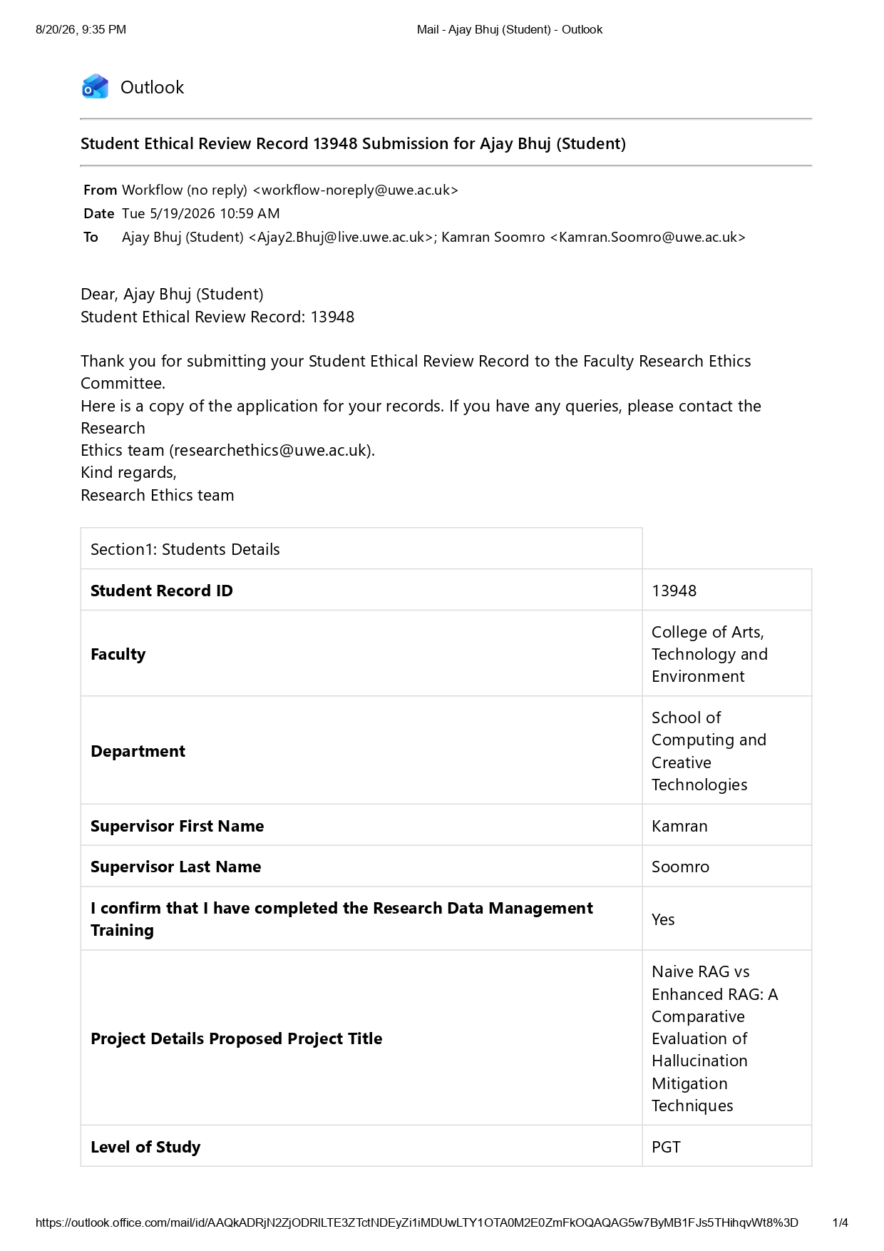
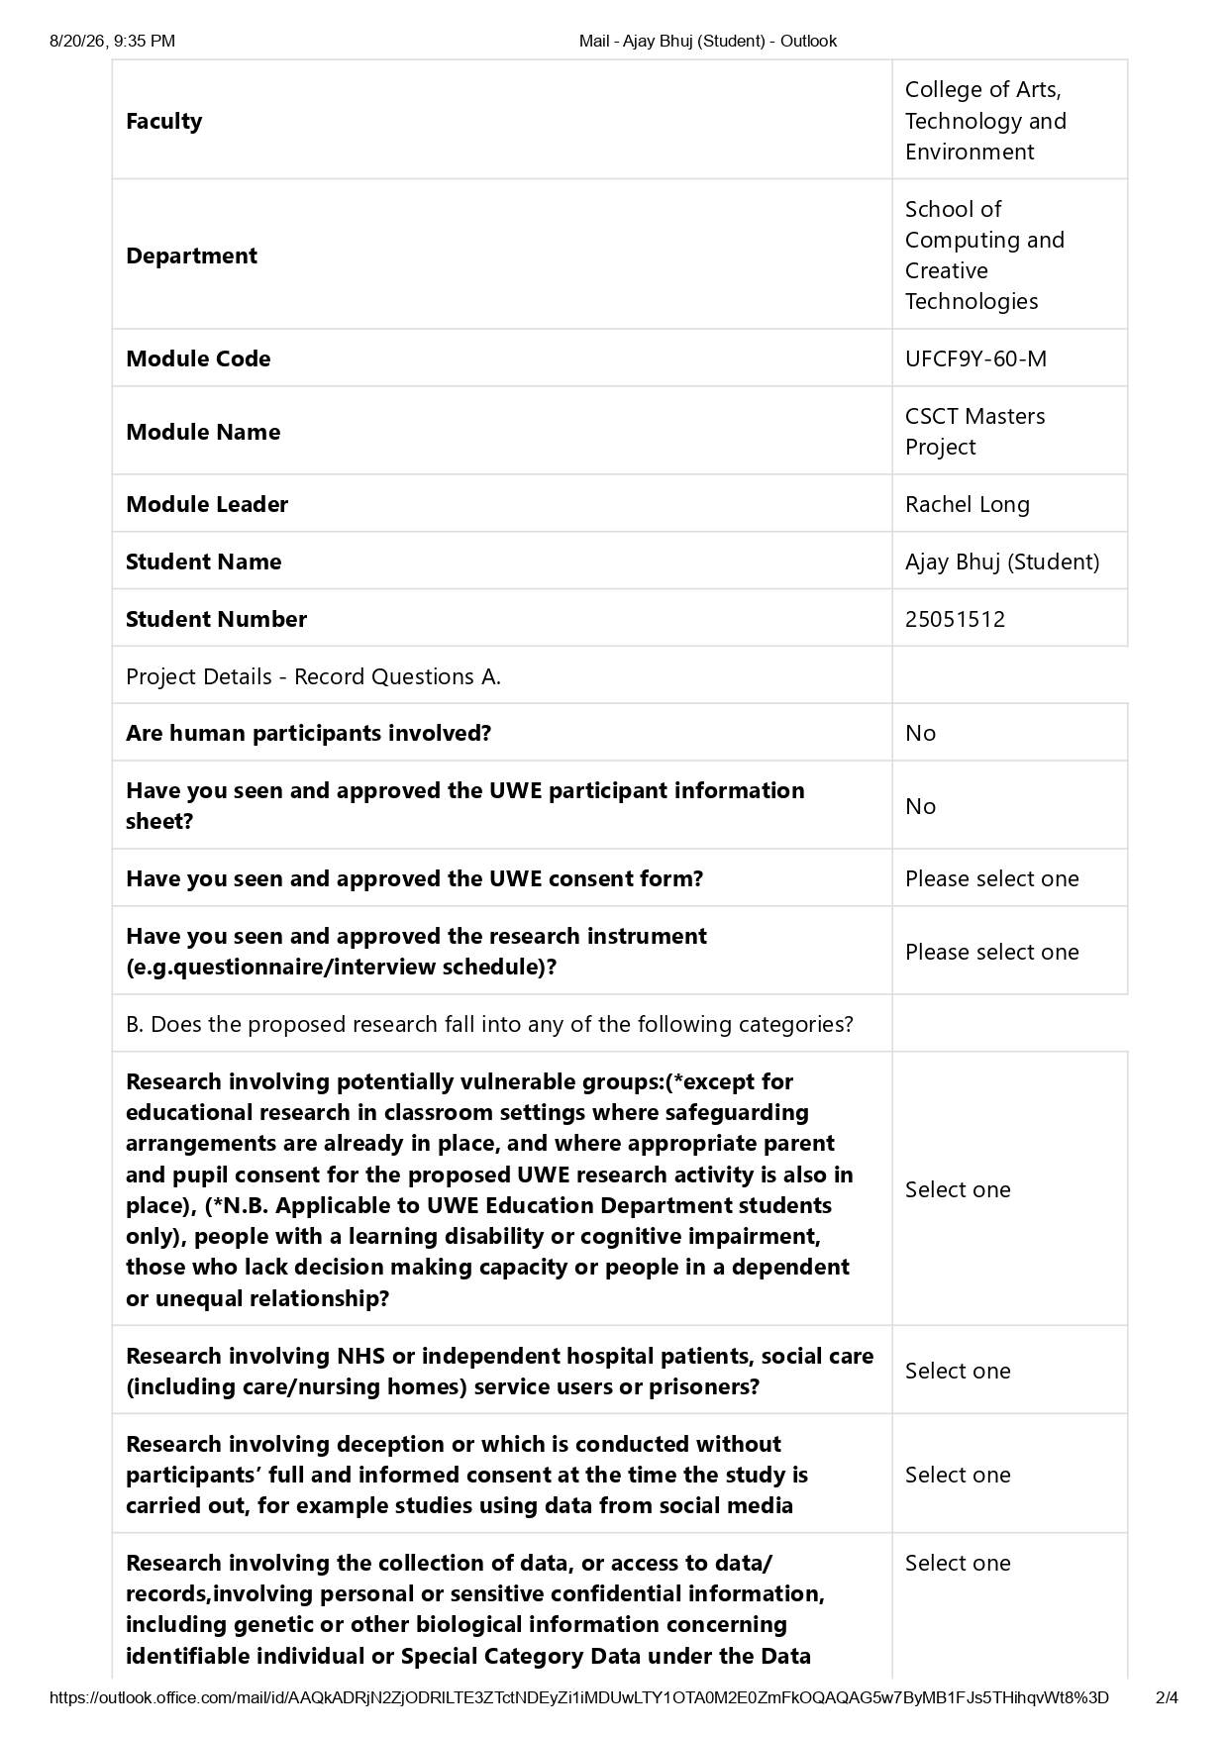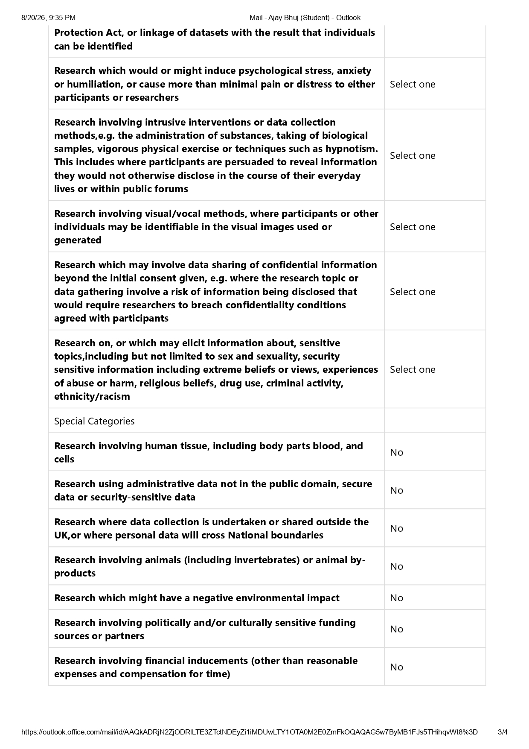

Appendix B: Record of supervision Meetings
Date | Discussed
19 May 2026 | Project proposal discussion, Presented the topic, the problem of hallucination in retrieval-augmented generation, and the intended shape of the artefact.
23 June 2026 | Discuss on the project Implementation plan
10 July 2026 | Demonstrated the first working implementation, the naive baseline answering questions over an ingested paper. Also, supervisor suggested some improvement and to add a experiment for the document vs performance measurement
29 July 2026 | Structure and presentation of the report. Discussed how the chapters should be sequenced, how the results should be presented
11 August 2026 | Presented the results of both the technique comparison and the corpus experiment. Discussed why contextual compression separates from the other techniques while the rest sit close to the baseline,

Appendix C: Gantt Chart

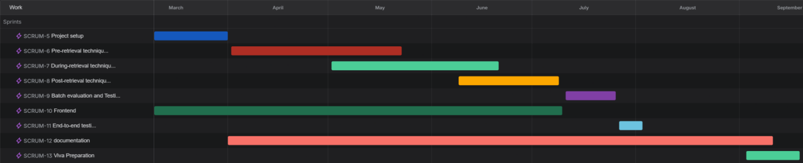

Appendix D: Benchmark Schema Example:

Factual Question Schema example:
{
"id": "q4",
"category": "factual",
"question": "How many fine-grained named entity types does the CORD-19-NER dataset cover?",
"ground_truth": "75 fine-grained named entity types",
"expected_passages": [
"This dataset covers 75 fine-grained named entity types.",
"Then we get a final entity type hierarchy with 75 fine-grained entity types used in our annotations."
]
}
Out-of-scope Question Schema example:

{
"id": "q14",
"category": "out_of_scope",
"question": "What precision, recall, and F1 does the NER annotation achieve against a manually labeled gold-standard test set?",
"ground_truth": null,
"expected_passages": []
}

Appendix E: Pipeline Design

Figure 14: The naive RAG baseline.


Figure 15: The three retrieval stages.

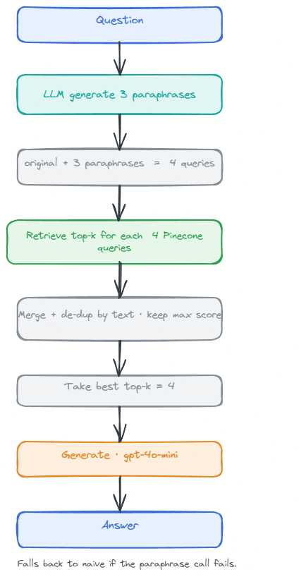
Figure 16: Multi-query retrieval.
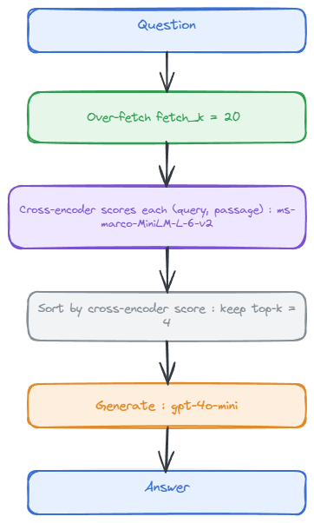
Figure 17: Cross-encoader reranker
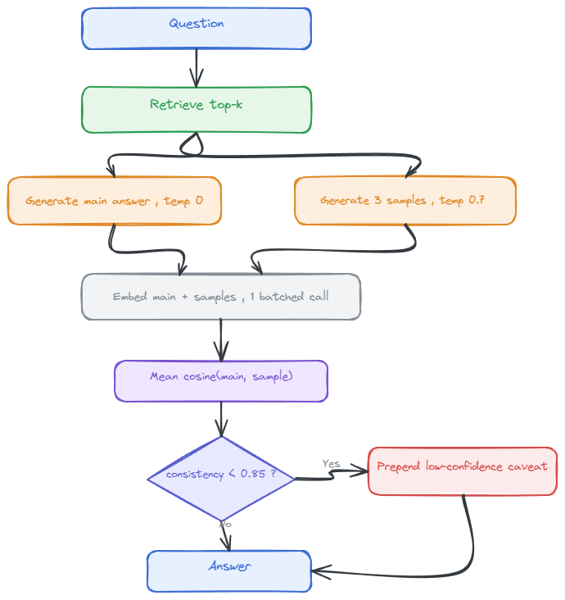
Figure 18: SelfCheckGPT
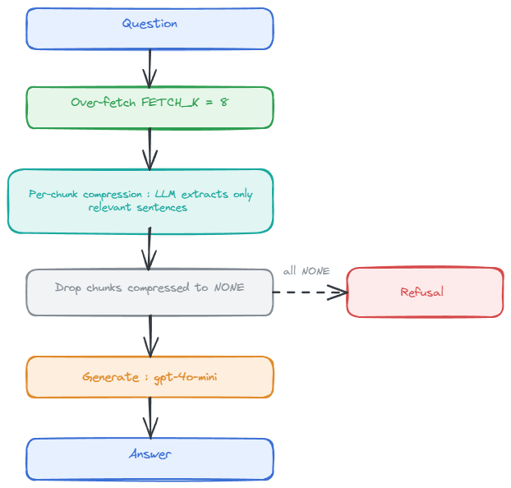
Figure 19: Contextual compression
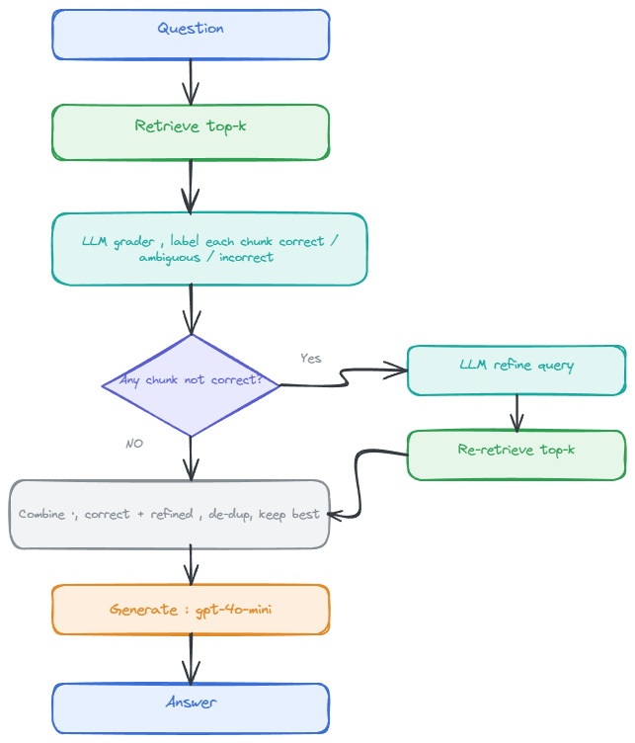
Figure 20: CRAG, corrective retrieval

